* **Activity 5:**

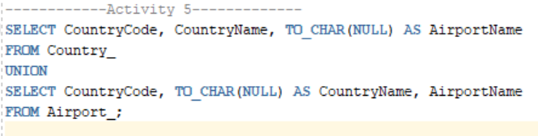Matching the SELECT Statements

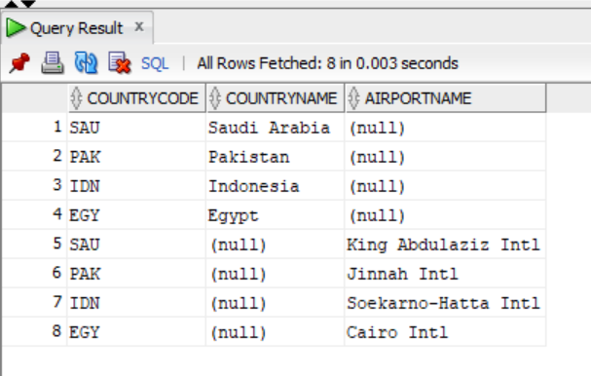OUTPUT: